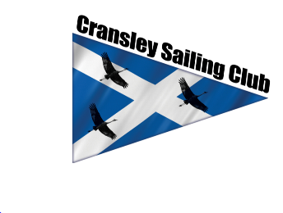
Cransley Sailing Club Clothing Order Form

Your Name | Mobile Number | Email

Item | Colour | Select one | Size | Cost | Total Cost
Hoodie | Navy | Child/Adult |  | £20/£25 | £
Hoodie | Cransley blue | Child/Adult |  | £20/£25 | £
Polo Shirt | Navy | Child/Adult |  | £12/£15 | £
Polo Shirt | Cransley blue | Child/Adult |  | £12/£15 | £
Add personalisation at £3 per garment |  |  |  | £3 per item | £
 |  |  |  | Total | £

Personalisation | Cost | Selected name (print)
Name under logo (embroidered) | £3
Name printed on back (screen printed) | £3

Junior Sizing - Age | 3-4 | 5-6 | 7-8 | 9-10 | 11-12 | 13
Chest size t-shirt | 22 | 24 | 26 | 28 | 30 | 32
Chest size Hoodie | 25 | 26 | 28 | 30 | 32 | 34

Adult Sizing | XS | S | M | L | XL | XXL | XXXL
Chest size t-shirt | 32 | 35 | 38 | 42 | 46 | 50
Chest size Hoodie | 34 | 36 | 39 | 43 | 47 | 51 | 56

Please complete the clothing order form and send to:
Sophie Guyett by What’s App - 07801 834499 or email sophie.guyett@icloud.com
Please check size ordered is correct as once your clothing order is made items cannot be returned.
Sorry, but we are unable to accept cash or cheques, payment to be made by
Bank transfer only please add your name and clothing as a payment reference:
Cransley Sailing Club - Barclays Bank
Sort code: 20-45-77 Account number: 40299456

